Topic 6.3: Sudoku Puzzle Solver
Question
Write a program to solve a Sudoku puzzle by filling the empty cells.
A Sudoku solution must satisfy all of the following rules:
- Each of the digits 1–9 must occur exactly once in each row.
- Each of the digits 1–9 must occur exactly once in each column.
- Each of the digits 1–9 must occur exactly once in each of the 9 sub-boxes of the grid.
The '.' character indicates empty cells.
Aim
To implement a backtracking algorithm to solve a partially filled Sudoku board, ensuring all Sudoku rules are satisfied.
Algorithm
- Start with the given Sudoku board.
- Find the first empty cell.
- Attempt to place digits 1–9 in that cell.
- For each placement, check if it is valid according to Sudoku rules:
  - The number is not already in the same row.
  - The number is not already in the same column.
  - The number is not already in the corresponding 3×3 sub-box.
- If valid, place the number and recursively attempt to solve the next cell.
- If no number fits, backtrack and reset the cell to empty, then try another possibility.
- Continue until all cells are filled.
Output
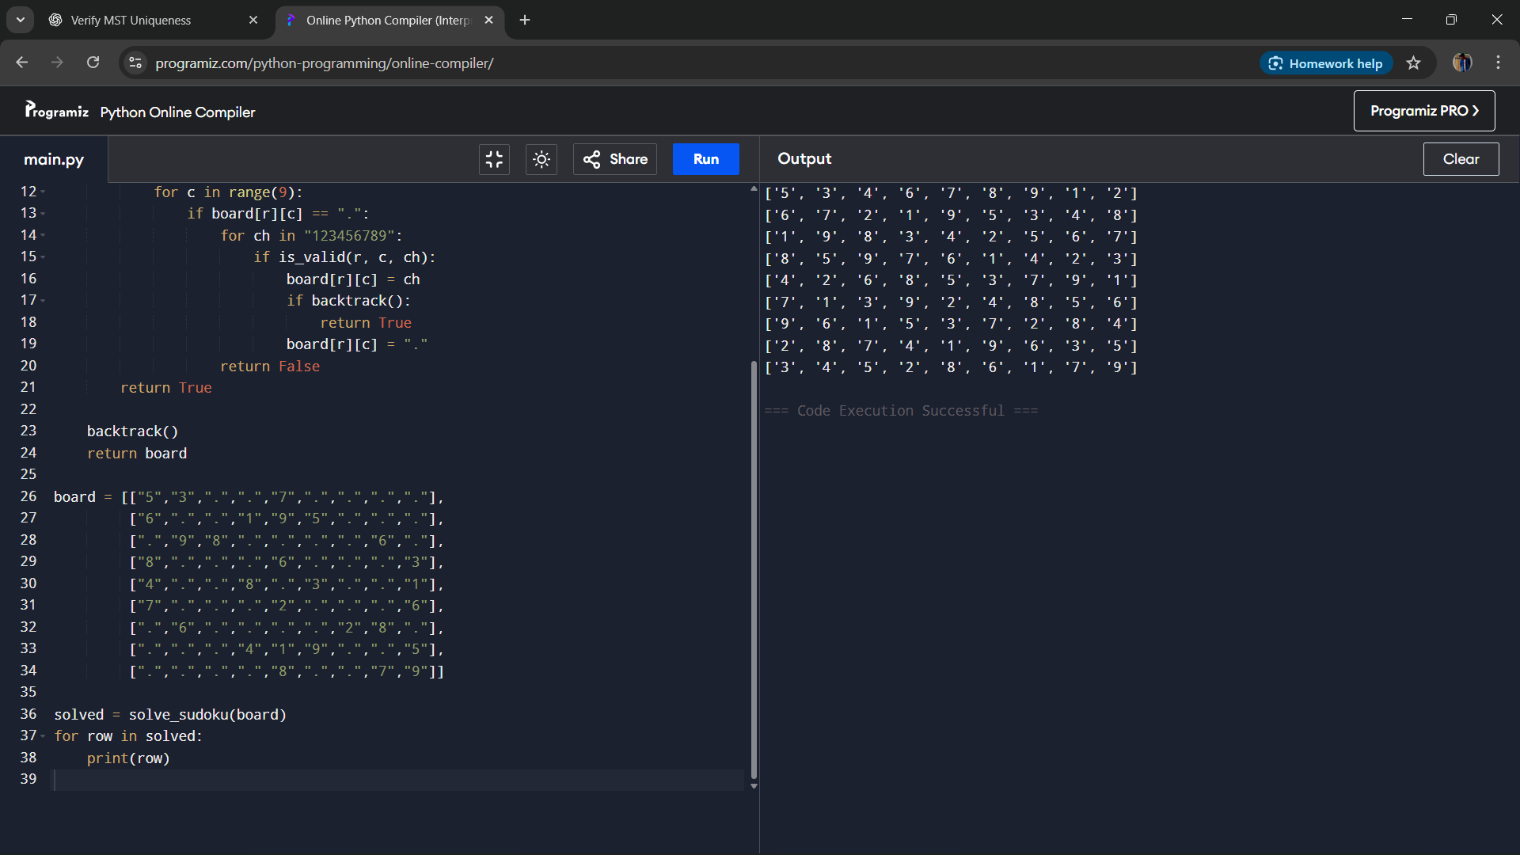
Result
The Sudoku puzzle was successfully solved by applying backtracking and constraint checking.
Performance Analysis
- Time Complexity: O(9^(n)) in the worst case, where n is the number of empty cells.
- Space Complexity: O(1) (constant board size 9×9) plus recursion stack depth O(n).

